Practical 7:-

Step 1: Open your salesforce account

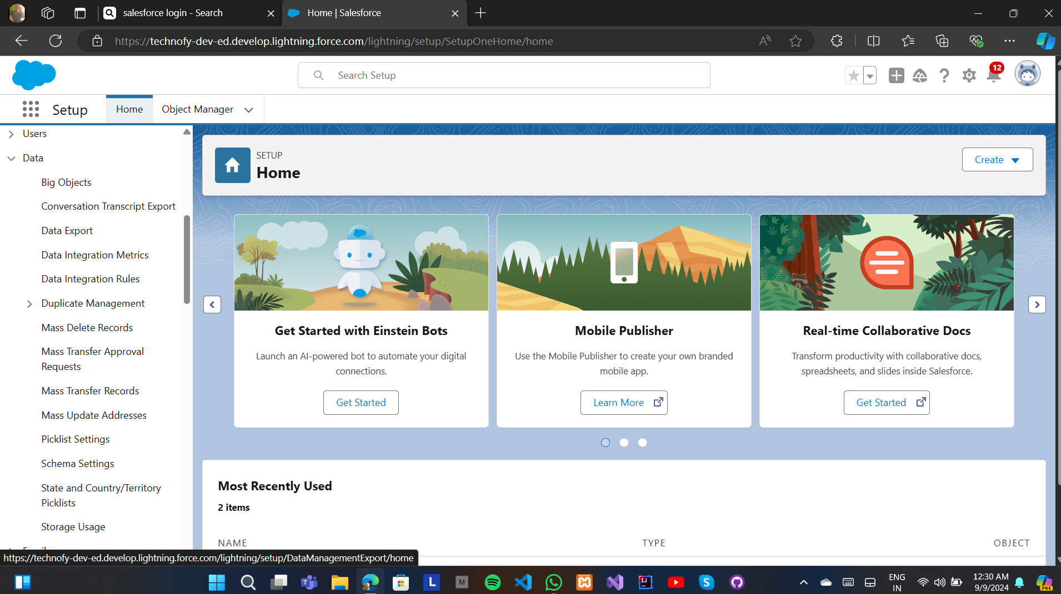

Step 2: Click on 9 dots on left side beside setup

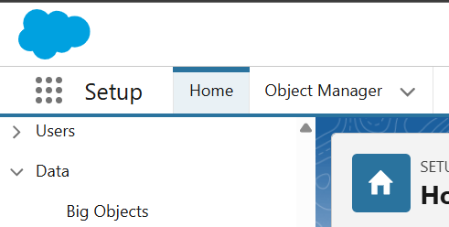

Step 3: Search Reports and click on new report

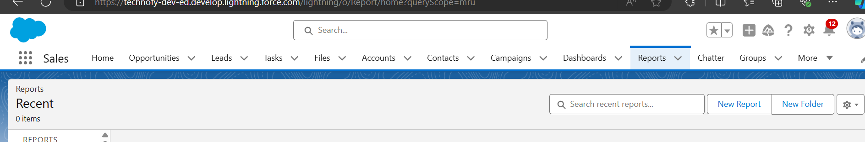

Step 4: Click on accounts and then on start report

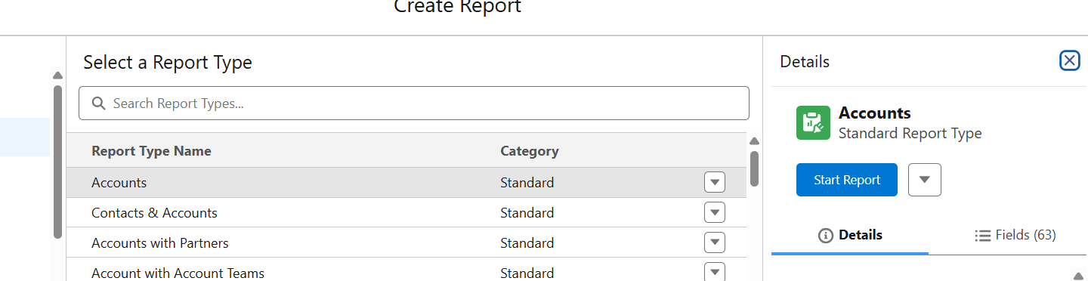

Step 5: Go to filters and click on created date

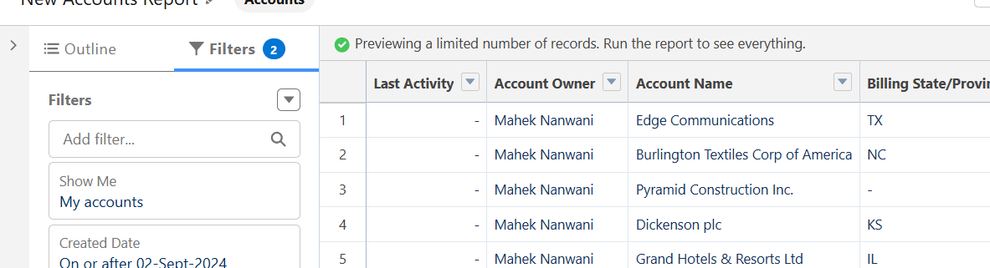

Step 6: Go to range and select ‘All time and apply’

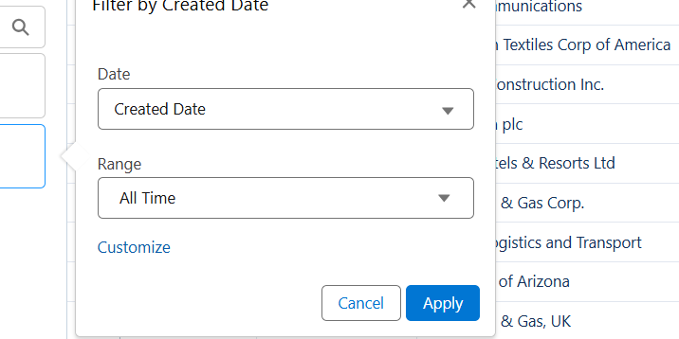

Step 7: Click on update preview automatically



Step 8: GO to add filter and search rating and select any value (hot,cold,warm) and then apply then save and run

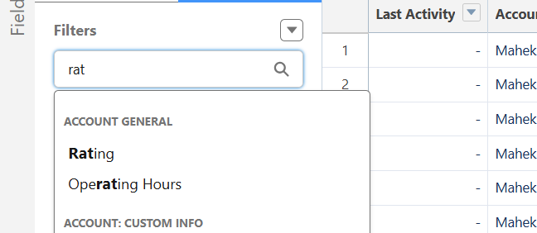

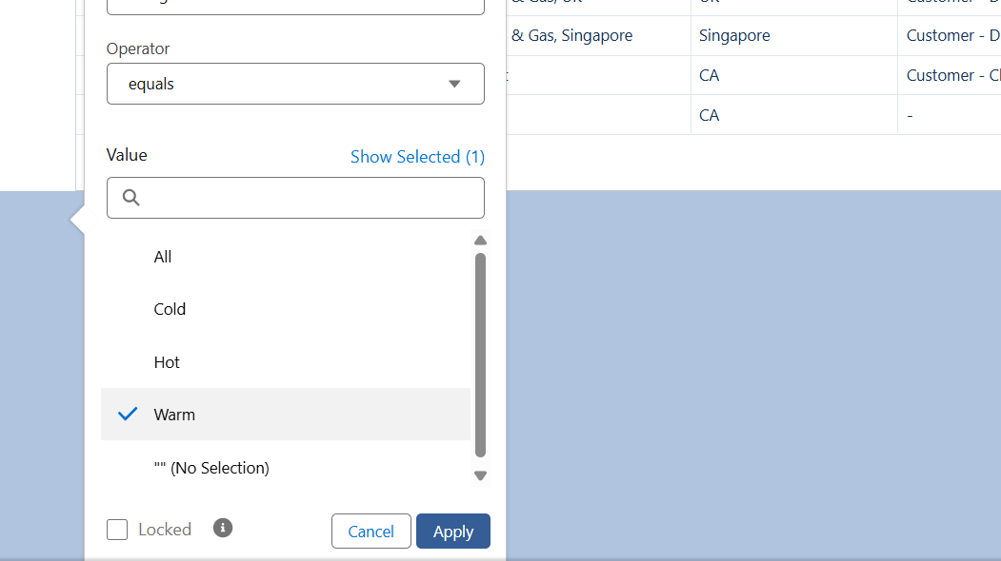

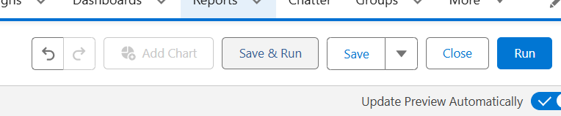

Step 9: Give it a name and go to select folder and click on new folder and give it a name and save and click on it and on save and then on save

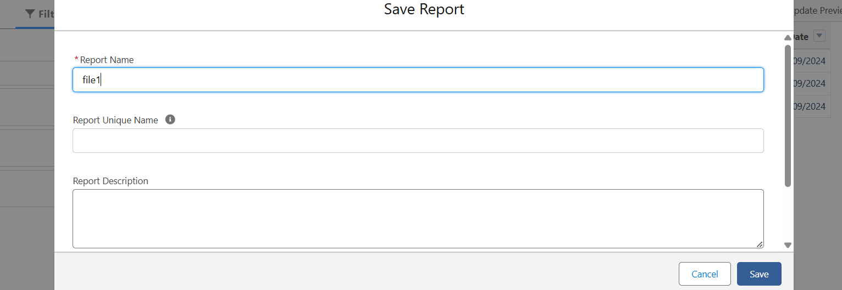

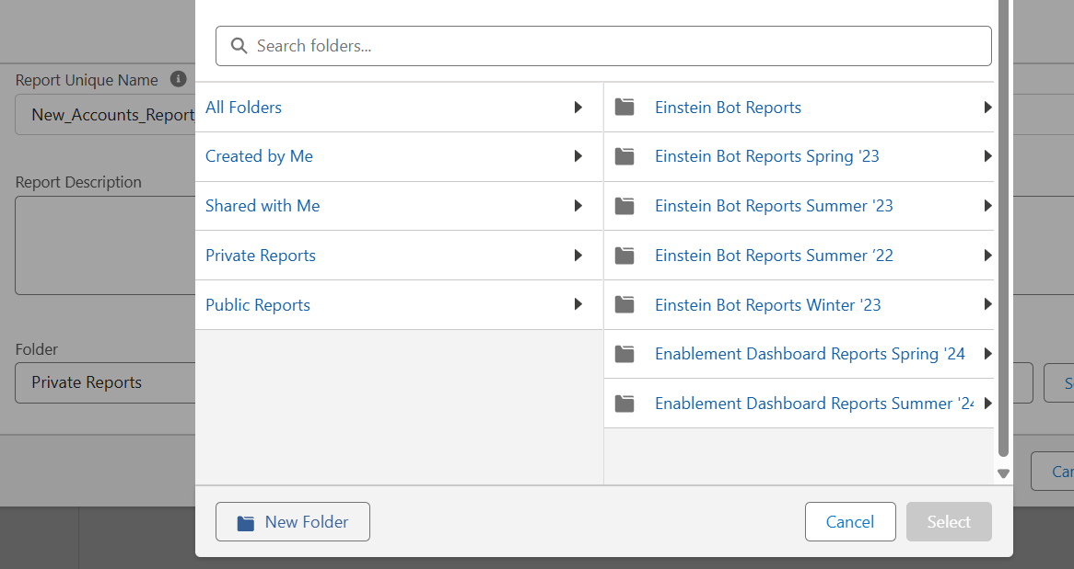

Step 10: Again click on 9 dots and search dashboards and click on new dashboards and give it a name, select it and click on select folder and click on ‘create’

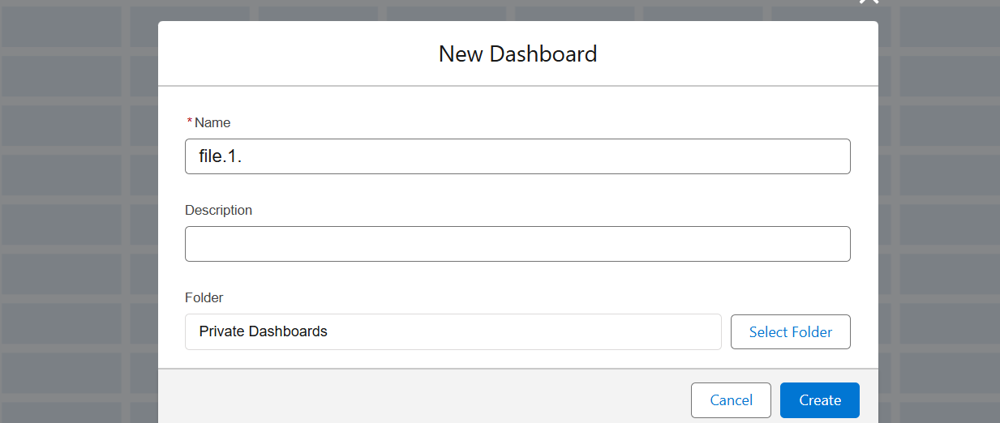

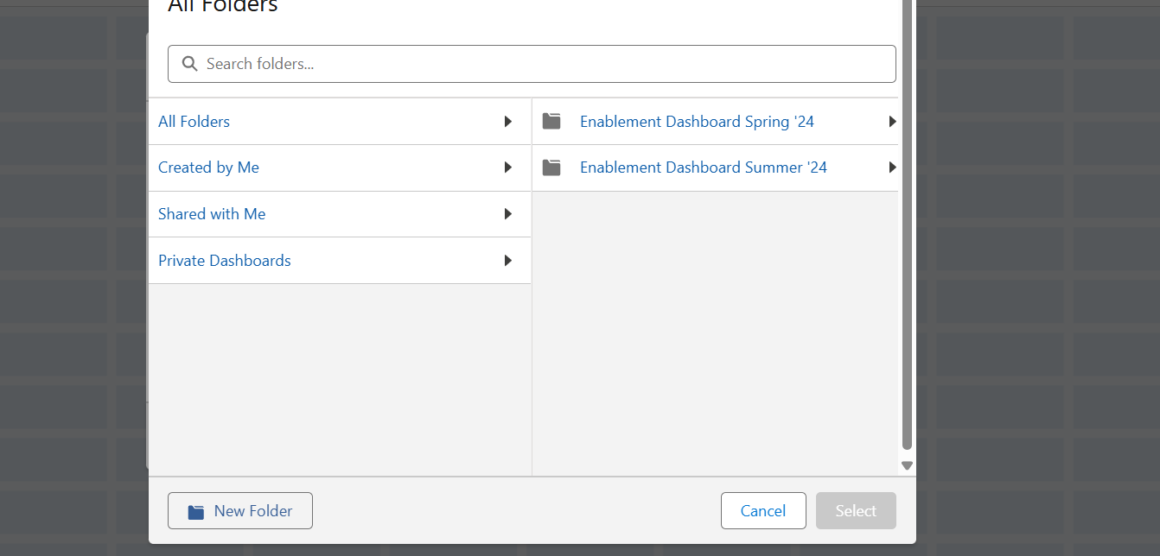

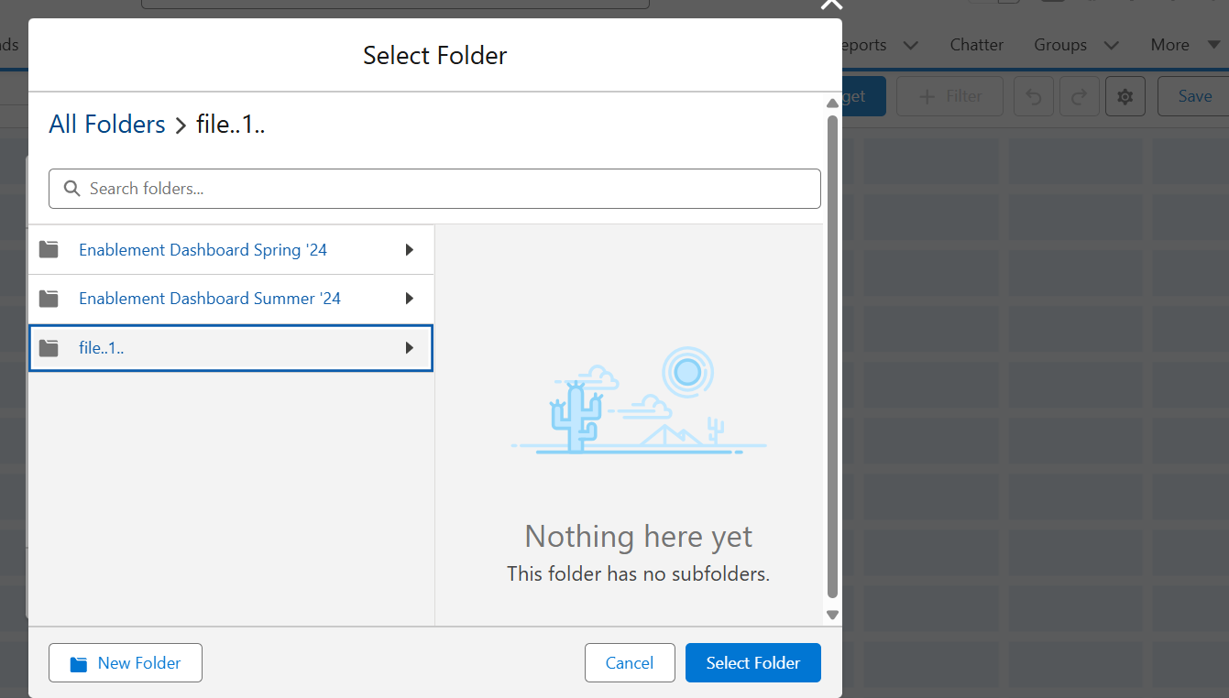

Step 11: Go to + Widget and click on chart or table

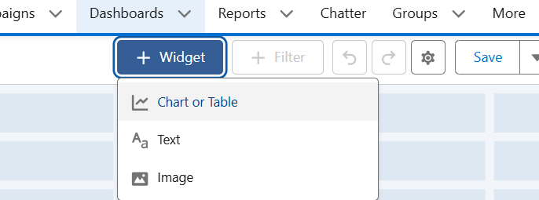

Step 12: Select your folder and and click on select

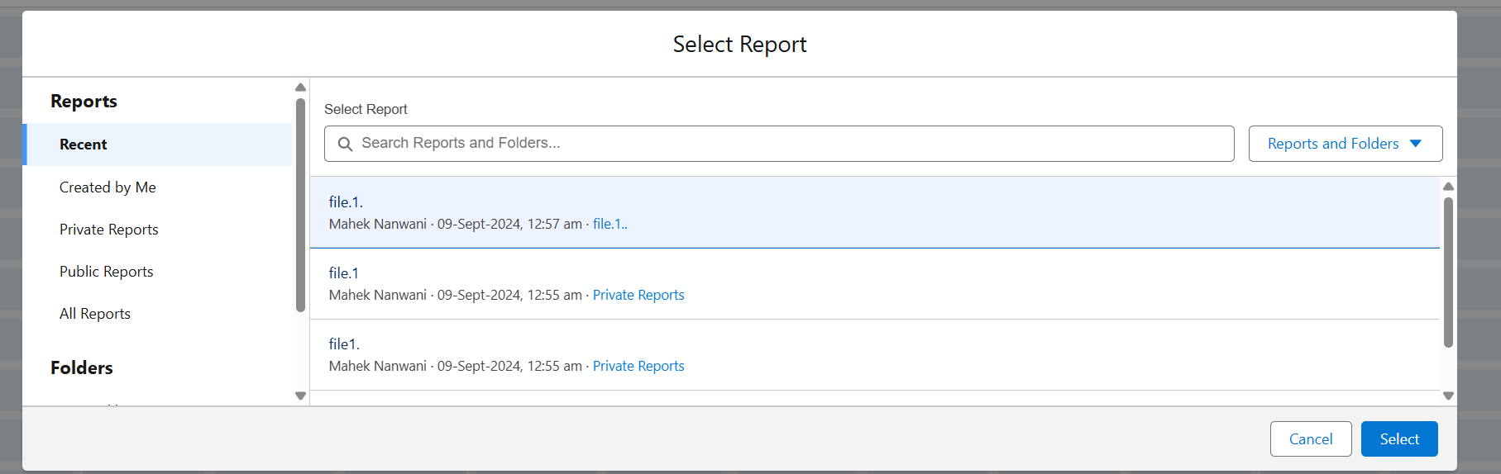

Step 13: Click on add

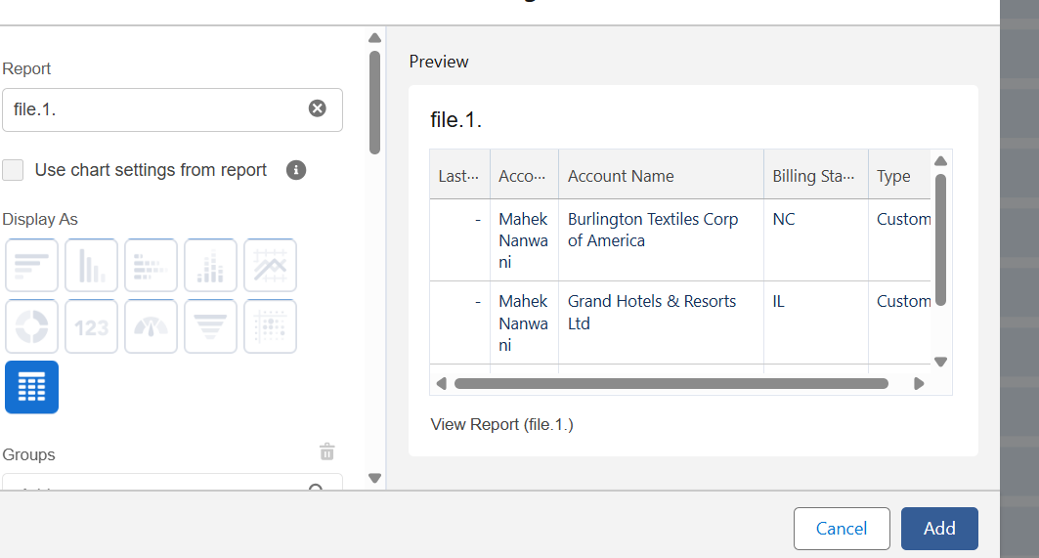

Repeat previous 3 steps

Step 14: Go to groups and select any datalike Account id and click add

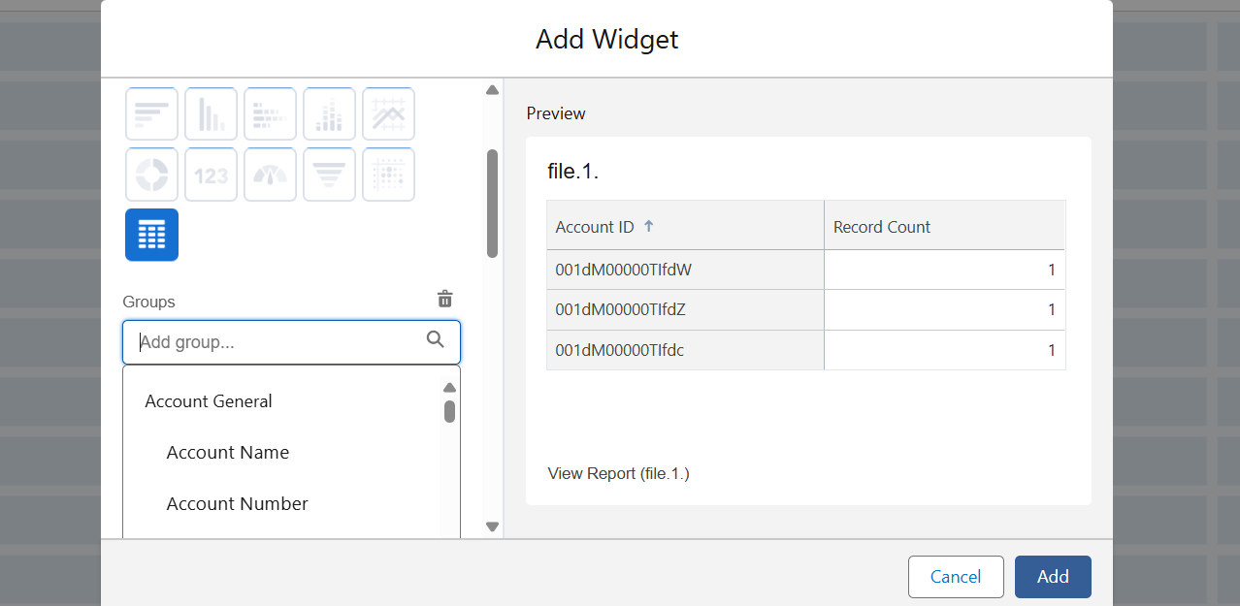

Step 15: GO to +Widget and select image and add a image and click on add and go to done and save

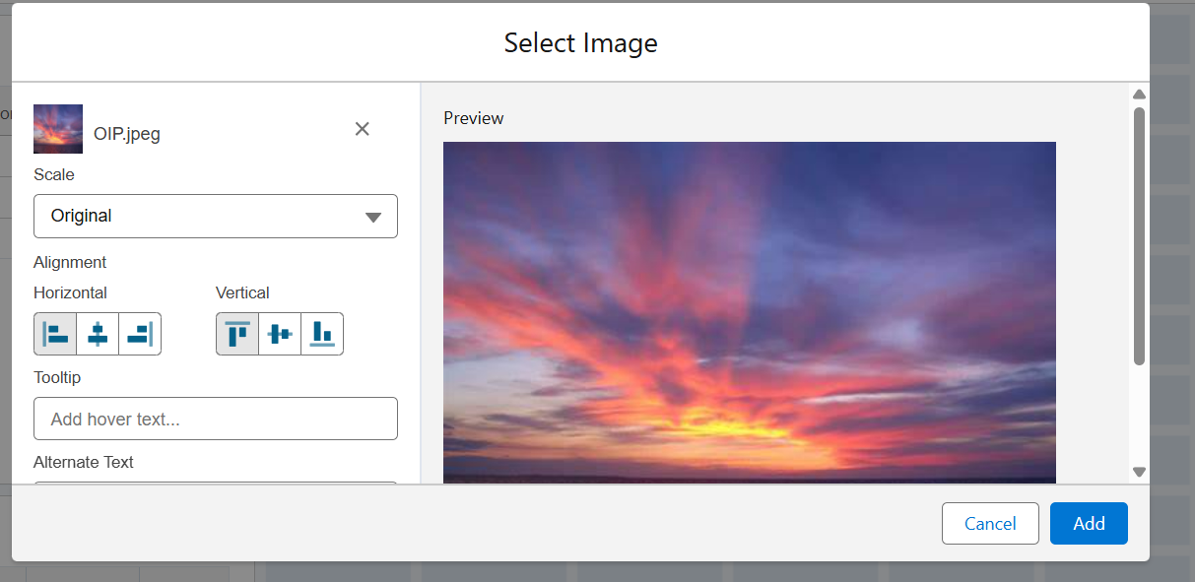

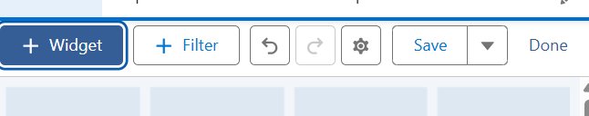

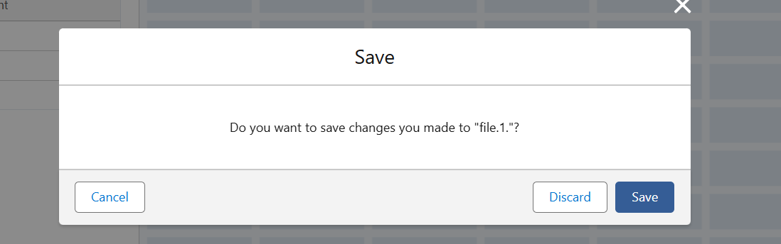

Step 16: Go to arrow and click on download

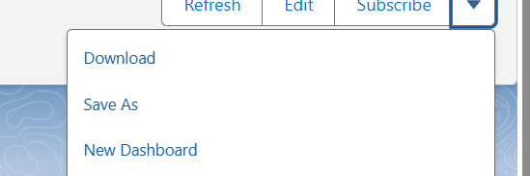

Step 17: Open file and see that your data has been there or not

